SPRING OFFER

Sparkling Wine

MASOTTINA – Conegliano, Italy NEW!  Masottina is a family owned operation based near Conegliano in the heart of Prosecco land which began in 1946 when Epifanio Dal Bianco started growing grapes in the region. The company is now run by his son, Adriano and two grandsons, Valerio & Renzo. Quality is at the heart of the company and this really shows through in the wines. They are classic expressions of Prosecco which delight at a great price. | 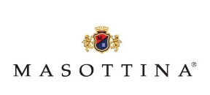
White Sparkling  Prosecco Riflessi |  | Vintage  NV | List Price  £10.50 | Offer  £9.49

Rose

D O M A I N E L’A N C I E N N E E C O L E – Vinsobres- France  We really love this Rose. It has such depth of flavour and oh my, what a colour! It is great for Spring because it isn’t ‘summer light’ and stands up well to most meals. Vibrant salmon hue and wonderful juicy summer red berry fruits such as raspberry and strawberry dance on the palate. | 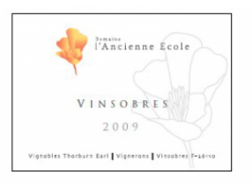
Rose | Vintage | List Price | Offer
Côtes du Rhône Rose | 2016 | £9.99 | £8.49

Whites
B R U N O A N D R E U – Languedoc- France
It’s always great fun tasting the new vintages with Bruno and Oriane. I’m always impressed at how good their fruit is and I love the way they blend the grapes together to make more balanced and interesting wines. They have a rustic, French country feel to them but are made in a clean, modern, forward thinking manner which makes them extremely appealing. They are a great advert for modern Languedoc wines with a great sense of artisan production, care and terroir for such humble wines. Peach, pineapple, lime, lemon grass, mineral finish. An excellent everyday wine and a particular ‘house favourite’ with Will and Christine.
Rose | Vintage | List Price | Offer
Roussanne/Sauvignon ‘Tendem’ | 2016 | £8.99 | £7.99
S A L A D I N I P I L A S T R I – Marche – Italy  This beautiful estate dating back to the 1400’s really impressed us. The estate is located in the south of the visually stunning Marche region, which sits on the east coast of central Italy. The climate here is Mediterranean with hot, dry summers tempered by the maritime influence of the Adriatic Sea only 8km away from the vineyards. All the farming is organic. A wonderful blend of Trebbiano, Passerina and Pecorino. Full, citrus, white pear, fresh apricot, mineral - better than many Pinot Grigios. A cracking ‘everyday’’ wine! The new 2016 vintage is better than ever… | 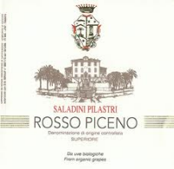
White | Vintage | List Price | Offer
Falerio dei Colli Ascolani | 2016 | £9.49 | £7.99

G R U P O Y L L E R A – Rueda – Spain
We had been looking to add a Verdejo to our list for a while. After tasting multiple Verdejos, this one got a collective cheer from the team. Harvesting is done at night to preserve the freshness of the grapes and the result shows. This wine is crisp, fresh and vibrant on the palate with green apples, grapefruit lemon zest and lychees and lovely texture.
White | Vintage |  | List Price | Offer
Verdejo ‘Vendimia Noctura’ | 2016 |  | £10.49 | £9.30

D O M A I N E D E S C H E Z E L L E S – Noyers sur Cher- France  This wine is made by Alain Marcadet who is one of the foremost producers in the Touraine. Touraine Sauvignon Blanc is often thought of as a cheaper alternative to Sancerre but we find it a unique style and a delicious expression of Sauvignon. | 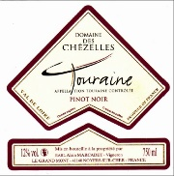
White | Vintage | List Price | Offer
Touraine Sauvignon Blanc, ‘Domaine des Bruyeres’ | 2015 | £10.79 | £9.49

C E L L A R C A L P L A – Priorat-Spain NEW!  Cellar Cal Pla is situated in the village of Porrera in the heart of Priorat. The vineyards are high up with an altitude ranging between 300m–500m above sea level. Cal Pla is only one of three producers in the whole of Priorat who make a Blanc. This is a superb unoaked blend of Macabeo (40%), Garnacha Blanca (30%) and Moscatell (30%). It is textured, rich, complex, leesy, really delicious and easily one of the best finds of 2018! | 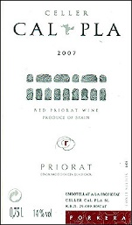
White | Vintage | List Price | Offer
Cal Pla Blanc | 2015 | £12.99 | £10.99

WEINGUT INGRID GROISS– Weinviertel NEW!  Describing herself as passionate, emotional and determined pretty much says it all about Ingrid and are the sort of character traits I’d expect to find in a young wine maker who modernised their parent’s winery. Having lived the corporate life with Coca-Cola in her younger years Ingrid returned to her wine making roots in Weinviertel and set about producing fantastic wines from the vineyards her granny planted some 50 years ago. Ingrid produces an expressive and pure style of Gruner which is a real treat. | 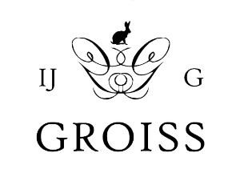
White | Vintage | List Price | Offer
Gruner Veltliner DAC | 2016 | £12.49 | £10.79

R A P A U R A S P R I N G S – Marlbrough – New Zealand
I’d be the first to admit that I’ve taken my eye off New Zealand recently. Maybe I’m just bored of the identikit Marlborough style. Certainly over the last 10 years many merchants quest to buy NZ Sauvignon became a bit of a race to the bottom with price more important than quality. That’s why, until now, we only listed one good Sauvignon from Marlborough. Then along came Rapaura Springs which slapped me in the face and woke me up again. The style is fresh and packed with expressive fruit – pink grapefruit, nectarine, passionfruit – along with lifted herbal notes and lovely mineral notes. It’s a beautiful style and when you look at the price of Sancerre it’s a real bargain!

White | Vintage | List Price | Offer
Sauvignon Blanc | 2016 | £12.99 | £10.99

S Y B I L L E K U N T Z – Mosel - Germany  Sybille took over her family estate in the early 80’s. She had opened a wine shop a few years earlier and realised that her parent’s wine was poor compared to others in the region. She thought she could do better and was right! Now certified organic Sybille’s wines have a complexity, freshness and modern appearance that puts them amongst the best in the region. The Qba Trocken zingy and super fresh- an absolute delight to have in the sun! The Spatlese (Late harvest) Trocken (Dry) is full, rich and packed with limey green fruit. |  | 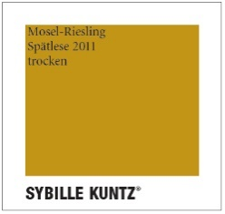
White | Vintage |  | List Price | Offer
Riesling Qba Trocken 2016 |  |  | £15.99 | £13.99
Riesling Spatlese Trocken 2014 |  |  | £25.99 | £23.99
Riesling Kabinett Trocken 2015 |  |  | £19.99 | £17.99

C O N S O L A T I O N – Côtes du Roussillon- France  If, like me, you are no stranger to daydreaming about packing everything up, loading it into the back of the car and heading to the south of France to purchase your ideal estate, then Coume del Mas is the one for you! Water feature in the driveway: check. Unknown but attractive vegetation growing up the walls: check. Extravagant plant pots: check. Outbuilding for when the in-laws come: check. World-class winery attached: check. Our old friend, Andy Cook, makes the Consolation range here – the boy landed on his feet!  These are serious, intense and rich wines but also really soft and approachable. We have chosen the Petit Gris for the offer because it is so different. The blend of Carignan Gris and Grenache Gris gives a racy and delicious minerality to the wine. | 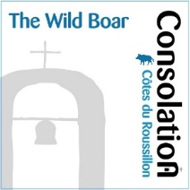
White | Vintage | List price | Offer
Petit Gris IGP Cotes Catalanes 2015 |  | £16.79 | £15.30

D O M A I N E H E N R Y N A T T E R- Loire – France NEW!  Brother and sister Mathilde and Vincent run this lovely estate which is located in the far south west of the Sancerre appellation. The estate was started in 1974 by their parents Cecile & Henry and now incorporates 23 hectares of vines. The Sancerre Blanc is from clay-limestone soils and is matured in foudres for 6 months which gives the wine a lovely richness and extra body without any real oak flavour. The wine is immediately impressive and delivers loads of citrus and stone fruit along with lovely mineral notes. | 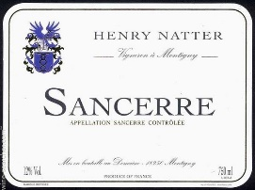
White | Vintage | List Price | Offer
Sancerre Blanc | 2016 | £17.50 | £14.99

REDS

B R U N O A N D R E U – Languedoc- France
It’s always great fun tasting the new vintages with Bruno and Oriane. I’m always impressed at how good their fruit is and I love the way they blend the grapes together to make more balanced and interesting wines. They have a rustic, French country feel to them but are made in a clean, modern, forward thinking manner which makes them extremely appealing. They are a great advert for modern Languedoc wines with a great sense of artisan production, care and terroir for such humble wines.
Red | Vintage | List Price | Offer
Merlot/Syrah ‘Tendem’ | 2017 | £8.99 | £7.49

B O D E G A S A L D O N I A – Rioja- Spain  The quality of the wines had always impressed me as had brothers Ivan & Mario Santos who are hell bent on producing a modern style of Rioja with minimal intervention that expressed both the grape and terroir. The problem I had was that they did not use the age categories which are so famous in Rioja. They believe that the grape is more important than aging a wine for a set period of time when it might not need it! For this reason their wines contain high proportions of Garnacha and do not have Crianza or Reserva on the labels. I was worried that they would not sell without the age classifications – I was wrong! It turns out they have proven to be tremendously popular and if you need further approval read Jancis’s write up in Purple Pages! She quite likes them also… | 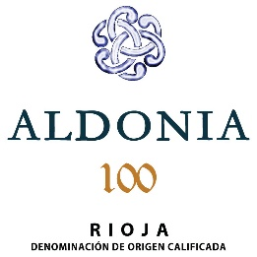
Red | Vintage | List Price | Offer
Rioja Vendimia | 2016 | £8.99 | £7.99

F R A T E L L I B A R B A– Abruzzo- Italy NEW!
Fratelli Barba is a family business established in the Abruzzo region since the 18th century. The estate covers 684 hectares, producing olive oil, dairy, orchard fruits, as well as wine. Over the last 25 years, Giovanni Barba has dedicated himself to constant quality in every aspect of their winemaking. The cellar built in 1991 is steadily modernised to implement higher quality each year. Montepulciano is generally viewed as just a soft and easy going red. This one in particular punches well above its weight with rich and complex notes of dark cherries, ripe red fruits, plums, spices, almonds and a lengthy mineral finish.

Red | Vintage | List Price | Offer
Montepulciano d’Abruzzo DOC | 2016 | £9.49 | £7.99

D O M A I N E D E S C H E Z E L L E S – Noyers sur Cher- France
This wine is made by Alain Marcadet who is one of the foremost producers in the Touraine. His Pinot Noir is amazing value for money with lovely bright, clean summer red fruit and some weight and power behind it. Pairs well with charcuterie.
Red | Vintage | List Price | Offer
Touraine Pinot Noir | 2016 | £10.99 | £8.99

C A S A S I L V A – Colchagua - Chile  In 1997, Mario Pablo Silva made a proposal to his father: he wanted to transform his bulk business into a prestige bottling company for export, bearing the family's own brand. Mario Silva accepted his son's challenge and Casa Silva was created. In a short space of time, Viña Casa Silva has become one of the most significant and awarded producers of premium Chilean wine. They have a pioneering spirit and own enviable vineyard sites which they match up to individual grape varieties. The Merlot is typically Chilean with soft juicy fruit and a velvety finish. |  | 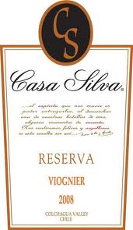
Merlot | Vintage |  | List Price | Offer
Merlot Reserva Coleccion | 2015 |  | £10.79 | £9.49

C E L L A R C A L P L A – Priorat NEW!
Cellar Cal Pla is situated in the village of Porrera in the heart of Priorat. The vineyards are high up with an altitude ranging between 300m–500m above sea level. The Cal Pla is a blend of Grenache, Carignan and Cabernet Sauvignon. It is aged for 13 months in 1-3 year old oak (majority French, some American), which results in a generous, heady, almost opulent wine that is packed with ripe dark berry fruit. The tannins are soft and the wine immensely drinkable.
Red | Vintage | List Price | Offer
Cal Pla Crianza Tinto | 2015 | £13.75 | £11.99

D O M A I N E L ‘ A N C I E N N E E C O L E – Vinsobres - France
We spent all last year searching for a Côtes du Rhône we liked and had almost given up when out of the blue Tarquin met a chap called Bill Thorburn in Edinburgh. It turns out Bill’s son, Wilson, and his wife, Anna, own a little estate called Domaine l’Ancienne Ecole just outside Vinsobres. “I’ll get you samples”, insists Bill. Now caution has to be taken here as it’s not uncommon for one of us to meet someone who knows someone who makes wine. It normally ends with a polite email including the words, “they were not right for us” (i.e. they were substandard). Thankfully Wilson and Anna’s wines were tremendous and we are proud to have them on our list. They are now certified organic from the 2014 vintage and their vineyards are in prime sites on the plateau above Vinsobres. Grenache dominated, the wines have excellent structure and above all are a pleasure to drink.

Red |  | Vintage | List Price | Offer
Côtes du Rhône |  | 2052 | £11.99 | £10.49

M A N O S N E G R A S – Mendoza - Argentina
Manos Negras was started by Jeff Mausbach and Alejandro Sejanovich who worked together at Bodegas Catena Zapata. There, they pioneered high altitude plantings and the development of Malbec clones. They understand the Malbec grape and how to get the best out of it. The Triuno is there entry level offering and the perfect introduction to the full, dark, brooding, yet delicately elegant Malbec style.
Red | Vintage | List Price | Offer
Triuno Malbec | 2015 | £9.99 | £8.49

C H A T E A U R I V A L B E L L E V U E – Bordeaux Superieur- France  The 2012 is a Merlot dominated blend with 10% Cabernet Sauvignon and 5% Cabernet Franc. It is soft, ripe, well-structured and dominated by luscious wild berry fruit and has the perfect balance of toasty, liquorice and spicy oak. It’s a delicious glass of wine at a modest price. | 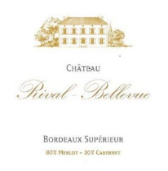
Red | Vintage | List Price | Offer
Chateau Rival Bellevue | 2014 | £10.79 | £8.79

C H A T E A U L A F L E U R– St Emilion- France  Located 1 km to the northeast of the town of St Emilion, this 8 hectare Chateau is made up of 70% Merlot, 20% Cabernet Franc and 10% Cabernet Sauvignon. The complex soils are made up of shallow clay-limestone, clay sand, shell debris and silt topsoil over a limestone subsoil. The wine is fully deserving of its Grand Cru status and displays that magic balance of elegance, finesse and complexity. The wine is fermented in stainless steel vats and matured in new French oak for 18 months. | 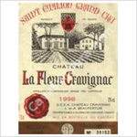
Red | Vintage | List Price | Offer
La Fleur Cravignac St-Emilion | 2014 | £19.99 | £17.49

C O N S O L A T I O N – Côtes du Roussillon - France
If, like me, you are no stranger to daydreaming about packing everything up, loading it into the back of the car and heading to the south of France to purchase your ideal estate, then Coume del Mas is the one for you! Water feature in the driveway: check. Unknown but attractive vegetation growing up the walls: check. Extravagant plant pots: check. Outbuilding for when the in-laws come: check. World-class winery attached: check. Our old friend, Andy Cook, makes the Consolation range here – the boy landed on his feet!
These are serious, intense and rich wines (please ask us about the others) but also really soft and approachable. They would certainly impress your guests at a dinner party!

Red | Vintage | List price | Offer
Syrah 'Wild Boar' Cotes du Roussillon 2015 |  | £16.79 | £15.49

